# watsonx Orchestrate Lab 4a:

# Using Decision Automation Flow

Objective

Another integral part of watsonx orchestrate is automating workflow. Besides that, we can also leverage the embedded Generative AI and decision components within the Projects section and insert it into a workflow (or just run as a single skill).

For this lab, we will be creating an automation workflow which will allow us to set some conditions to place order. The conditions can be for example if an order meets the minimum order requirement or budget requirement. Different condition will result in different results.

Prepare the zip file

For the purpose of this workshop, you will be uploading a copy of a pre-fabricated object.

1. Download the project file from [here](https://ibm.box.com/s/2or0v4cccava4i6ls3cpmvr4x7ur1p1p) and save to your desktop.
2. If you are using a shared instance, we will need to ensure our project name does not clash with one another.
3. Navigate to your desktop, unzip the file and rename the file to [YourName]_Reorder_automation.

1. Zip up the file again after you’ve renamed.

*** **If you are using a Macbook, the current built in archiver utility is not compatible. To rezip your folder please follow the following steps or please ask a facilitator to assist you.**

1. **Launch terminal**
2. **Paste in this code and press return:**

***cd desktop***

1. **Paste in this code and press return:**

**zip -r [YourName]_Reorder_automation_demo.zip [YourName]_Reorder_automation_demo**

Create a Project

1. Return to Watsonx Orchestrate. Click on the Projects tab.
2. From the menu, select **Skill studio**.
3. In the **Skill studio** page, click **Create**, and select **Project**.
4. Select Import automation and select the zip file which you’ve processed in the first section [YourName]_Reorder_automation.zip and click import

Build a Workflow

1. After importing the project, you will see that a few components have been created for you.

* 1. Decision models help simplify and visually organize how decisions are made, using a clear, structured diagram. These diagrams show how decisions connect with the needed information. The process involves breaking down big decisions into smaller, manageable ones.
  2. Workflows can be used to design an automation flow using skills from the catalogue and from other components from within the project. There is an option to hand over tasks to relevant parties if necessary.
  3. Generative AI allows user to create prompt and using Large Language Model to generate text which can be utilised within workflows and skills catalogues.

1. Feel free to click on the different created components and look at the inner workings of the different projects component.
2. Earlier on, we were using a skill called AutoAI to calculate the reorder quantity. The model has been pre-imported into the environment.
3. We will now walk through the process on how to import this model which has been deployed in our watsonx platform.
4. Click On Time Series Model within the Decision section.

1. You will see a flow diagram like this. If the model is not configured, you will see a yellow exclamation mark on the ML model invocation tile

1. Click on the exclamation mark on the tile if there is.

1. Click on Connect

1. Choose “Remote machine learning model” and click Next (top right)

1. Set up a New Provider

1. Click on New

1. Give it a name. As for the rest of the details, refer to the “Connection Details” list given to you, under “Auto AI Connection”.
2. Test the connection once you’ve filled in all the details.

**\*\*If you are facing error, check that your API key/Space ID and URL does not have a space at the end.**

1. Once the setup is done, you will see a service provider created for you

1. Click Back to [YourName]_TimeSeries on the top left and click on the exclamation mark again.
2. Select the Model provide you’ve created.

1. Select the Auto AI P10 BATS Model

1. Do not change the input schema and proceed to test.
2. Click Run on the Test Invocation section.

1. Once it is successful you can click Next and click on “Generate from test output”

1. Click Apply to finish the set up. The exclamation mark should changed to a purple M.
2. Now we will learn how to create a automation workflow. The full workflow is as shown in the diagram.

1. For this lab, we will only build a portion of it.
2. Click on Create Skill at the bottom left and select Workflow

1. Name your Workflow “[YourName]_Reorder_Decision_Demo” and click Create

1. Each workflow requires its own set of variables. Let’s create those first.
2. Select your workflow, and navigate to the “Variable” section at the top of the page

1. Create a new variable by clicking on “Create Variable”

1. Type in “ReorderQty” in the Name column.

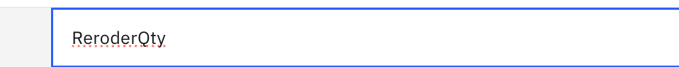

1. Select “Number” in the Data type column and toggle Yes for the Input column



1. The full details of our first variable are as follow.



1. Repeat steps 9-11 until you get a list of variables like this:

1. After creating the variables, navigate back to Diagram

1. Remove the templated skill .

1. Just like in skill flows, we can add different components within our flow.Click on the “+” sign and click on Decision(1).

1. Add in Get Reorder Qty

1. Get Reorder Qty requires 2 inputs, we will need to map it with the variables we’ve created. Click on “Define data mapping” on the right.

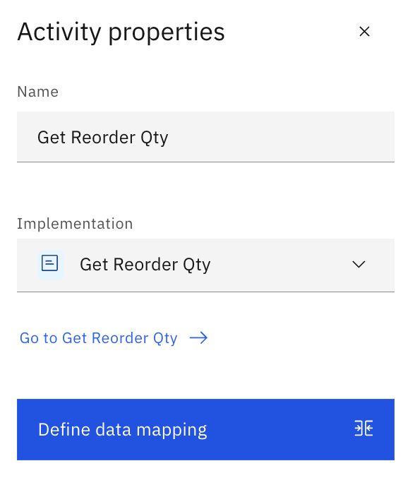

1. Select a variable

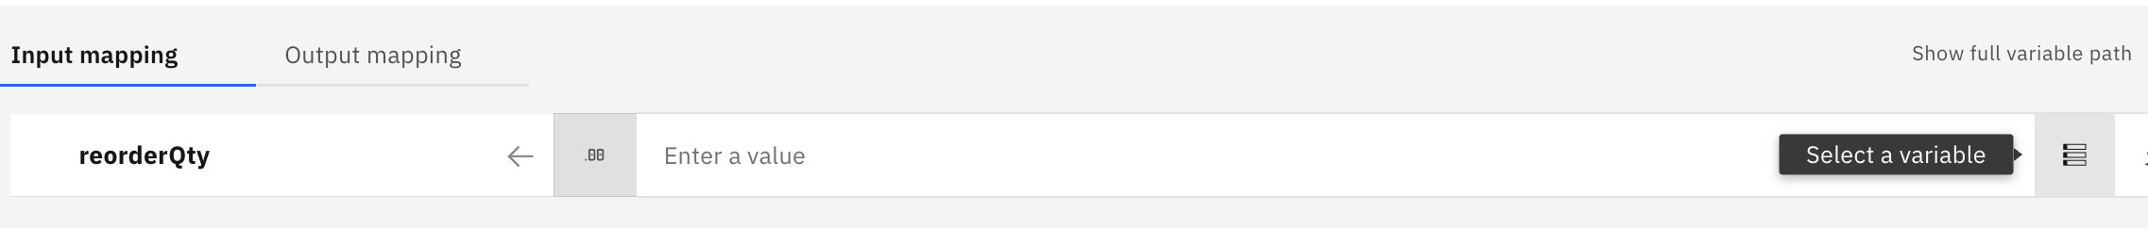

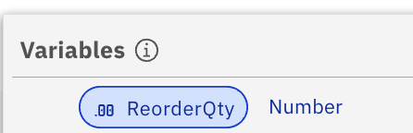

1. Repeat for unitPrice but selecting UnitPrice variable as mapping

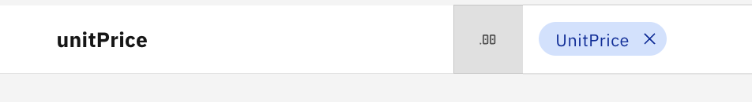

1. Navigate to output mapping and map to ReorderValue. Click Ok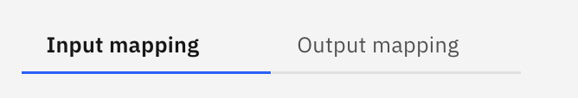

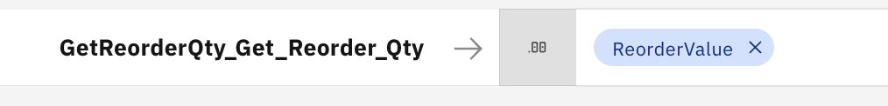

1. Now, we will include a branch, to check if the order meets minimum order requirement. Select the “+” and look for “branch”

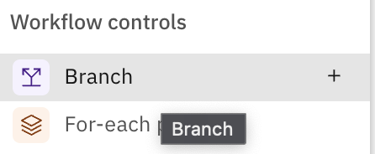

1. Rename the path name to MinOrderMet

1. We will add in some condition. Click on Edit conditions

1. Set the condition to be true if ReorderQty is greater than or equal to 2000. This number is just an arbitrary number and xan be change,

1. Let’s get the system to send a notification to the user if a minimum order is not met. We will be using one of our pre-prepared Generative AI skill.
2. Click on “+” on the else route.

1. Click on Generative AI and select “No min order notification”

1. Click into the tile and define the data mapping. Click OK once the input and output mapping is done.

1. Let’s test this flow locally for now. Click on the play button at the top right corner and Select New Instance

1. For the ReorderQty, put a number that is less than 2000 and Unit Price can be any value. Once you’re done, click Run.

**\*\* You may need to allow pop out window for this step.**

1. There will be a new window/tab appear showing you a sample output.

1. For orders which met the minimum order, let’s have the system to create a Draft order in Salesforce automatically.

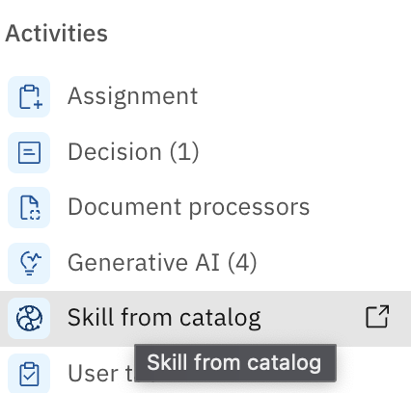

1. Input and Output mapping for Create an Order in Salesforce. The date can be any date you want.

1. You can run a test just like in step 49-50, using Reorder Qty more than 2000. This time you will see the return as success with no messages.

## Publish the Workflow

1. Share the changes.

1. Click on Publish and put in a version name.

1. Navigate back to Skill Studio, you will see your workflow being published under Skills and Apps tab. (May need to refresh the page).
2. This is only part of the flow. To understand how we build the whole flow, you can refer to the rest of the steps.

[READ ONLY]

1. We will add in another branch to check if the order value is within budget.

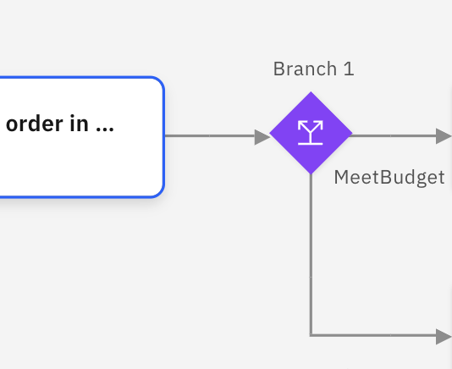

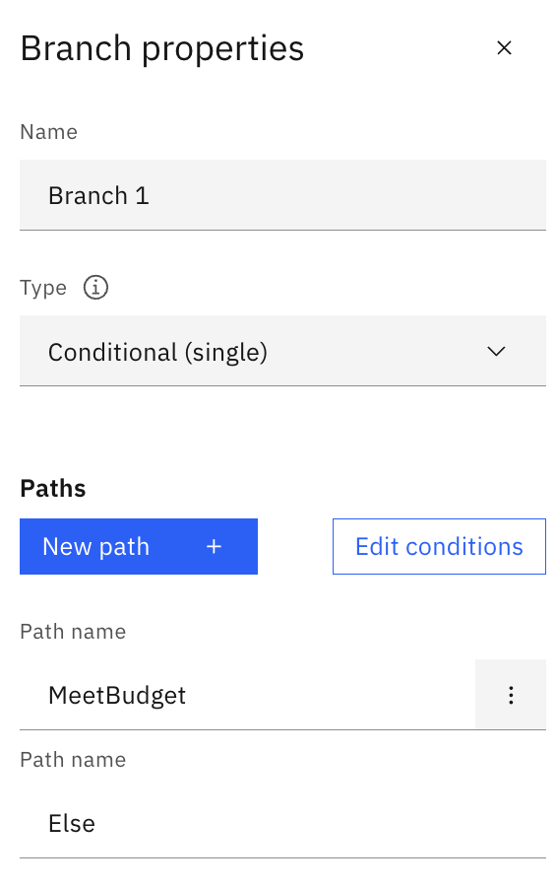

1. For orders which met the budget, we can also include a Generative AI notification and finalise the order with item details and unit prices.

1. Input and Output mapping for Order met.

